Integration test

# Version history

|  |  |  |  |
| --- | --- | --- | --- |
| Editor | Date | Version | Description |
| Patrick | 20 Feb 2021 | 1.0.0 | Initial release |
| Patrick | 8 Mar 2021 | 2.0.0 | Add test cases for custom grid size and file input |
| Patrick | 2 Apr 2021 | 3.0.0 | Add test cases for "PLACE_OBSTACLE" command |

Table of Contents

Version history 2

Welcome page 6

Case: Should be able to show welcome page when the application is launched 6

Grid size 7

Case: Should be able to allow user to input grid size, before handling file input 7

Case: Should be able to set default grid size, if grid size input is empty 8

Case: Should be able to throw error if width input is greater than the upper limit 9

Case: Should be able to throw error if width input is less than the lower limit 10

Case: Should be able to throw error if height input is greater than the upper limit 11

Case: Should be able to throw error if height input is less than the lower limit 12

Case: Should be able to throw error if the input is invalid 13

File input 14

Case: Should be able to process commands from file first, before waiting for user manual input on console, if file exists 14

Case: Should be able to wait for user manual input on console directly, if file is not found in the designated location 16

Case: Should be able to process the commands in file input correctly 17

Case: Should be able to process the file even if there is empty line at file end 18

Case: Should be able to throw error if any of the commands is invalid 19

Case: Should be able to rename file after processing 20

Manual console input 21

Case: Should be able to throw error if user input is empty 21

Case: Should be able to throw error if command is invalid 22

Case: Should be able to throw error if the PLACE command has invalid format (More than 2 parts including the command) 23

Case: Should be able to throw error if the PLACE command has invalid format (More than 3 elements in the part of the params) 24

Case: Should be able to throw error if the MOVE command has more than 1 part (it should contain only the command) 25

Case: Should be able to throw error if the LEFT command has more than 1 part (it should contain only the command) 26

Case: Should be able to throw error if the RIGHT command has more than 1 part (it should contain only the command) 27

Case: Should be able to throw error if the REPORT command has more than 1 part (it should contain only the command) 28

PLACE command 29

Case: Should be able to place the robot on the table 29

Case: Should be able to throw error if the x-coordinate param is not an integer 30

Case: Should be able to throw error if attempt to place the robot on the table with the x-coordinate < 0 31

Case: Should be able to throw error if attempt to place the robot on the table with the x-coordinate > 5 32

Case: Should be able to throw error if the y-coordinate param is not an integer 33

Case: Should be able to throw error if attempt to place the robot on the table with the y-coordinate < 0 34

Case: Should be able to throw error if attempt to place the robot on the table with the y-coordinate > 5 35

Case: Should be able to throw error if the facing is invalid 36

PLACE_OBSTACLE command 37

Case: Should be able to place obstacle 37

Case: Should be able to throw error if attempt to place obstacle but robot does not have location 38

Case: Should be able to throw error if attempt to place obstacle when robot is at east fringe 39

Case: Should be able to throw error if attempt to place obstacle when robot is at south fringe 40

Case: Should be able to throw error if attempt to place obstacle when robot is at west fringe 41

Case: Should be able to throw error if attempt to place obstacle when robot is at north fringe 42

MOVE command 43

Case: Should be able to move robot east 43

Case: Should be able to move robot south 44

Case: Should be able to move robot west 45

Case: Should be able to move robot north 46

Case: Should be able to throw error on MOVE command if robot does not have location 47

Case: Should be able to throw error if robot will fall off table after moving east 48

Case: Should be able to throw error if robot will fall off table after moving south 49

Case: Should be able to throw error if robot will fall of table after moving west 50

Case: Should be able to throw error if robot will fall of table after moving north 51

Case: Should be able to throw error if robot will hit an obstacle after moving east 52

Case: Should be able to throw error if robot will hit an obstacle after moving south 53

Case: Should be able to throw error if robot will hit an obstacle after moving west 54

Case: Should be able to throw error if robot will hit an obstacle after moving north 55

LEFT command 56

Case: Should be able to turn the robot to face north if it is facing east 56

Case: Should be able to turn the robot to face west if it is facing north 57

Case: Should be able to turn the robot to face south if it is facing west 58

Case: Should be able to turn the robot to face east if it is facing south 59

Case: Should be able to throw error on LEFT command if robot does not have location 60

RIGHT command 61

Case: Should be able to turn the robot to face south if it is facing east 61

Case: Should be able to turn the robot to face west if it is facing south 62

Case: Should be able to turn the robot to face north if it is facing west 63

Case: Should be able to turn the robot to face east if it is facing north 64

Case: Should be able to throw error on RIGHT command if robot does not have location 65

REPORT command 66

Case: Should be able to report the robot's location only when obstacle is not yet placed 66

Case: Should be able to report both the robot and obstacle's location only when obstacle is yet placed 67

Case: Should be able to throw error on REPORT command if robot does not have location 68

Logging 69

Case: Should be able to log system logs 69

Case: Should be able to log error logs related to program run 70

Case: Should not show the logs in the console 71

# Welcome page

## Case: Should be able to show welcome page when the application is launched

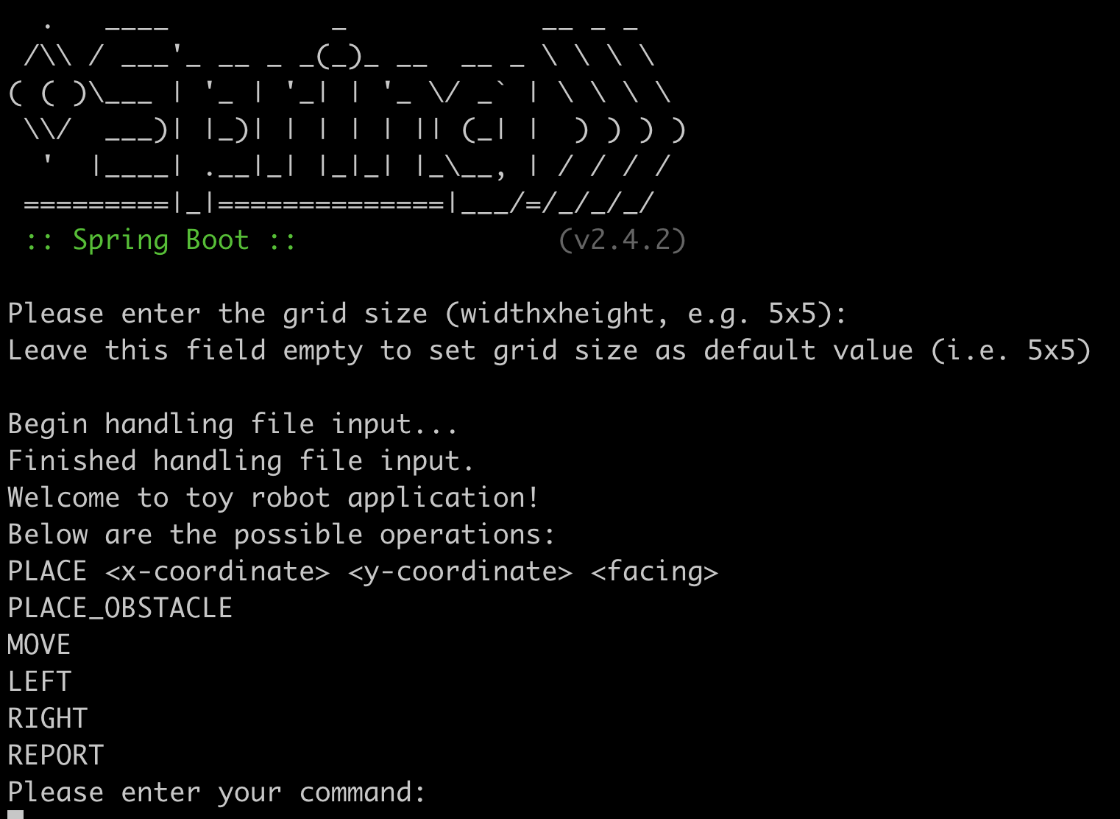

# Grid size

## Case: Should be able to allow user to input grid size, before handling file input

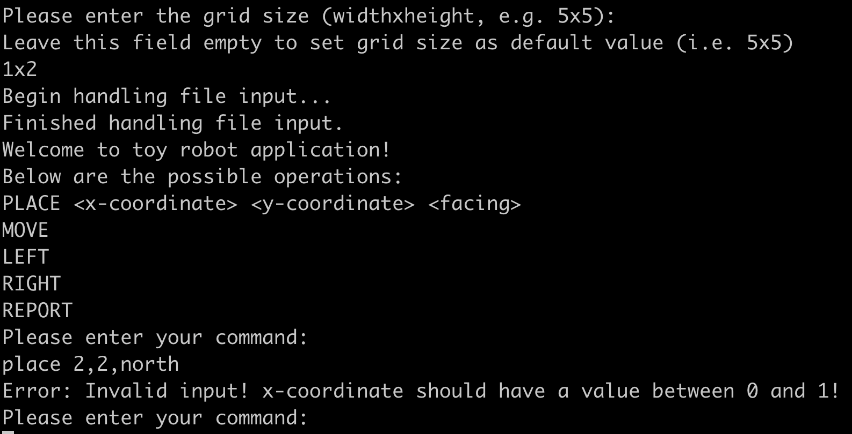

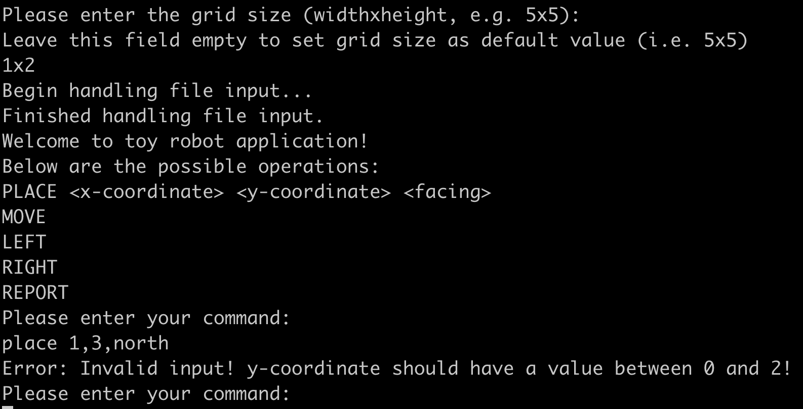

## Case: Should be able to set default grid size, if grid size input is empty

Expected grid size:

5x5

Result:

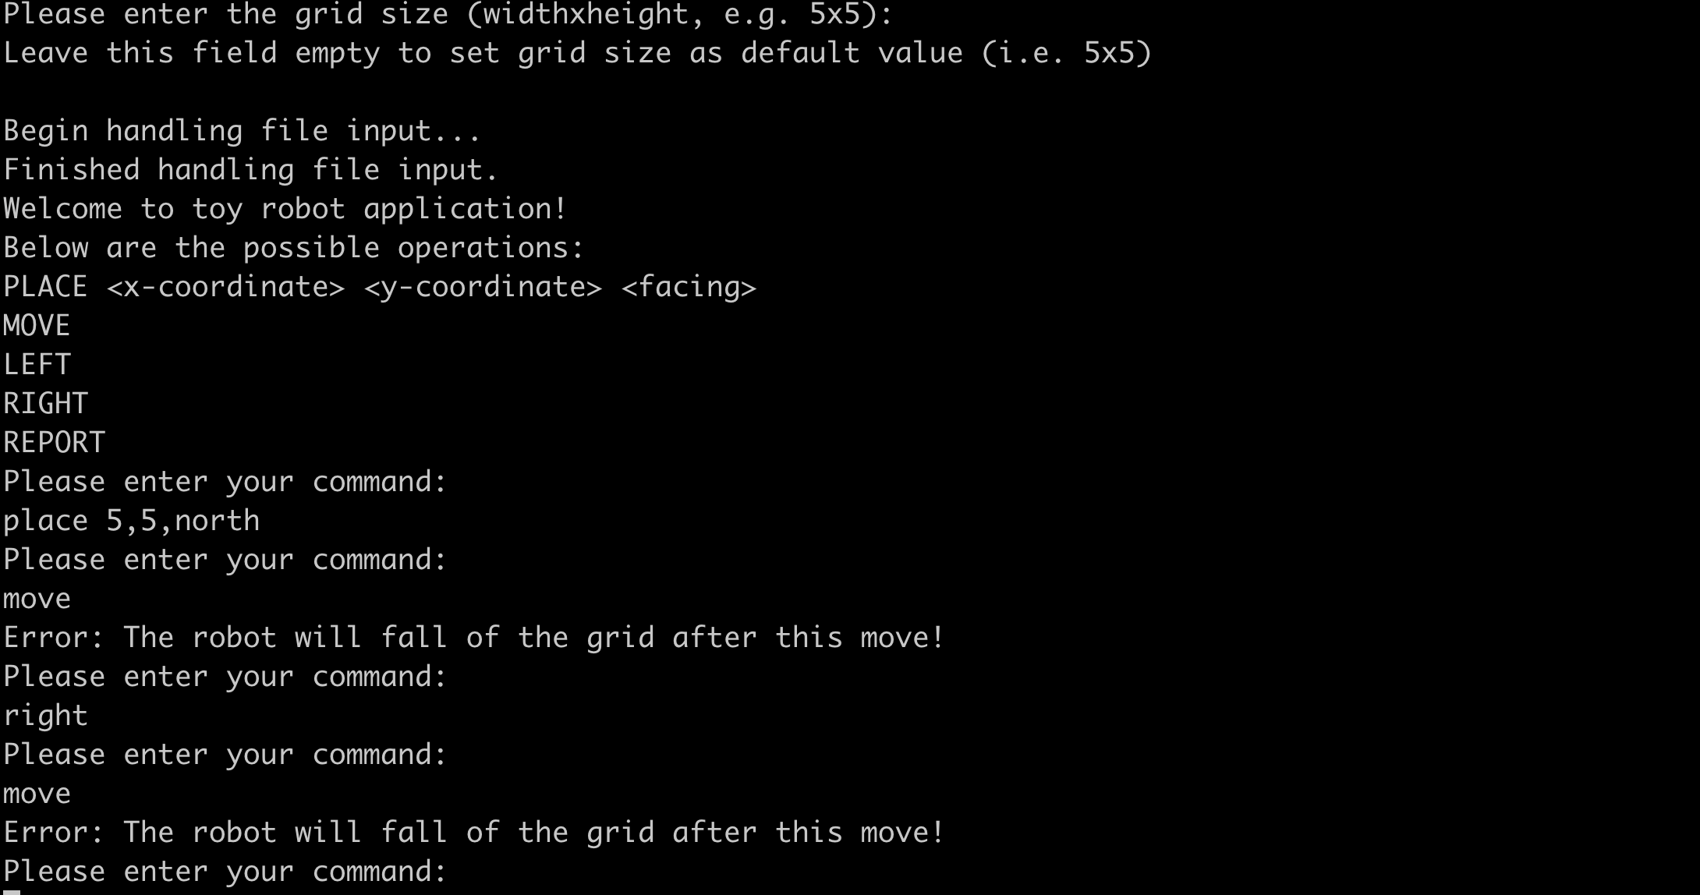

## Case: Should be able to throw error if width input is greater than the upper limit

Allowed grid size limit:

100x100

Result:

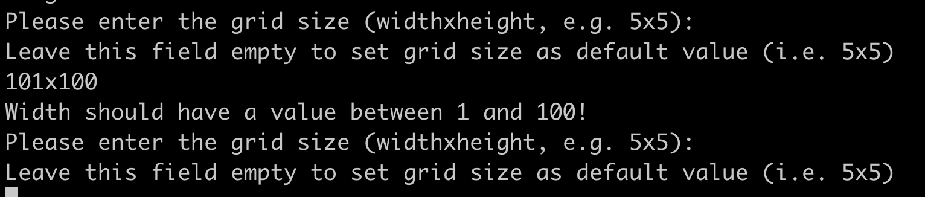

## Case: Should be able to throw error if width input is less than the lower limit

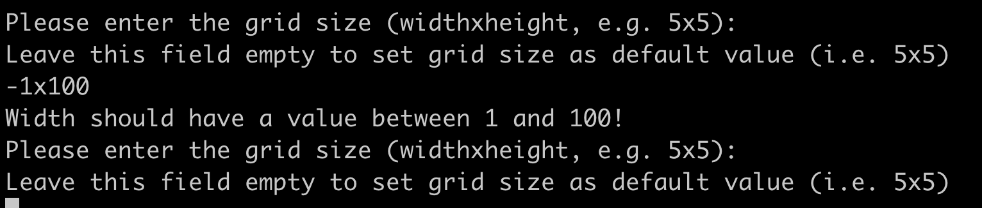

## Case: Should be able to throw error if height input is greater than the upper limit

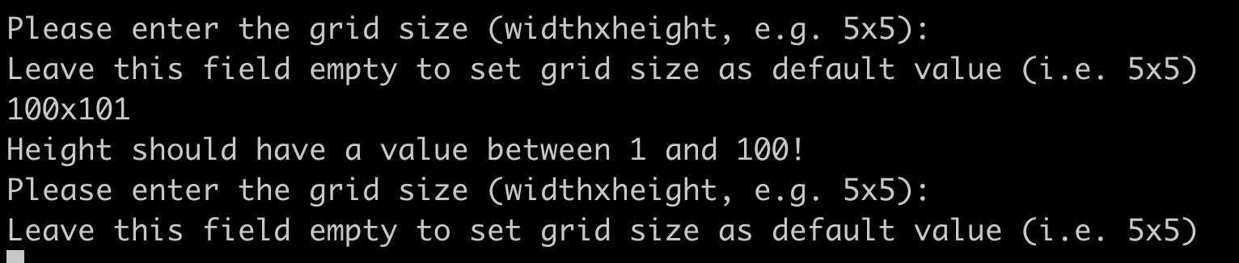

## Case: Should be able to throw error if height input is less than the lower limit

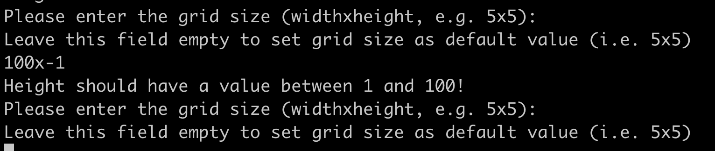

## Case: Should be able to throw error if the input is invalid

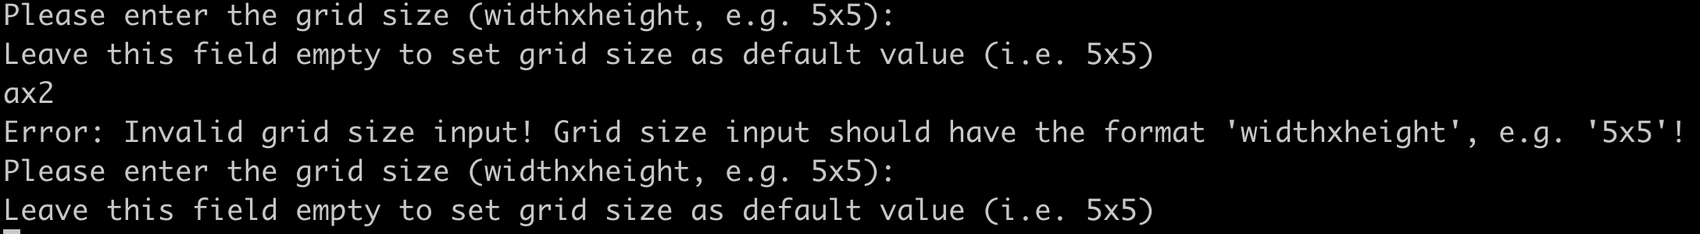

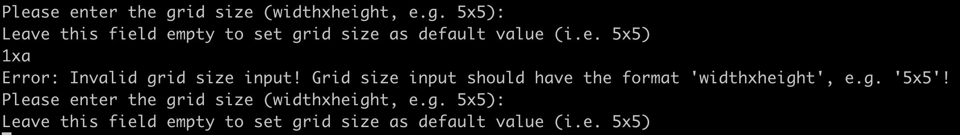

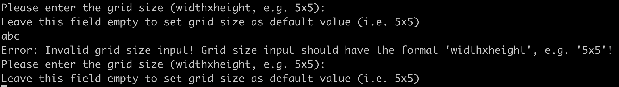

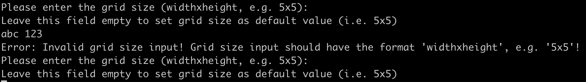

# File input

## Case: Should be able to process commands from file first, before waiting for user manual input on console, if file exists

File location

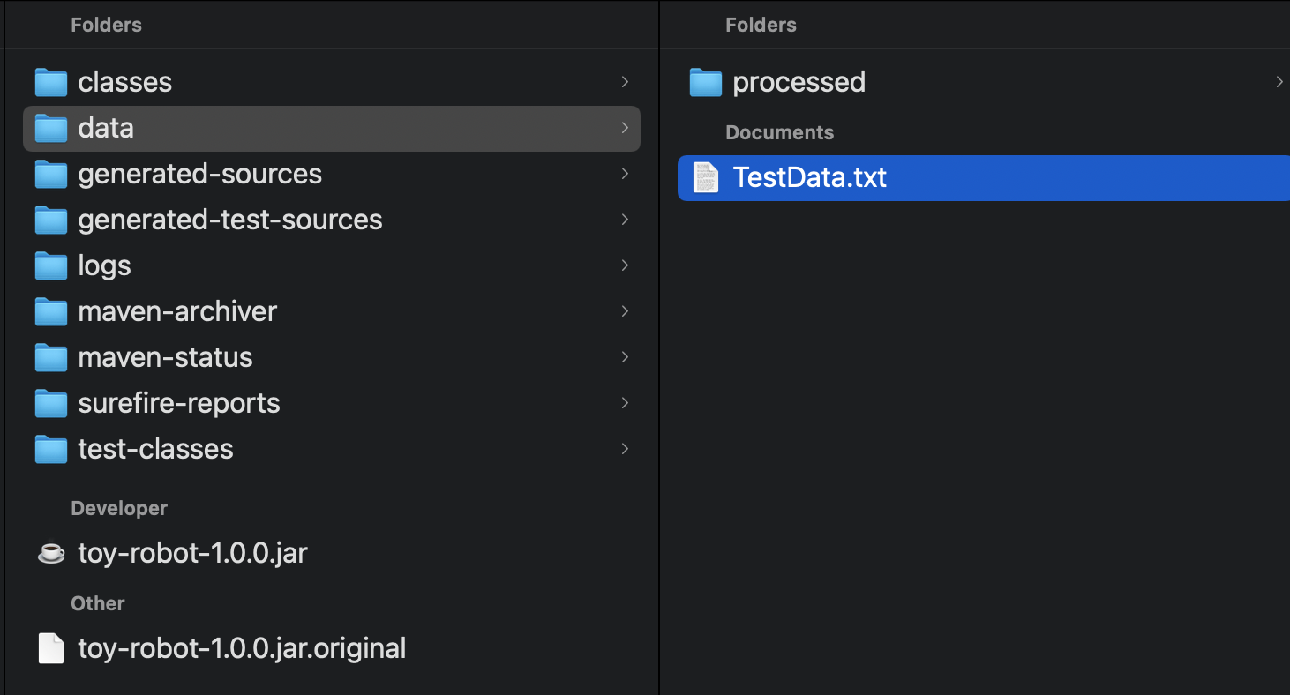

File content

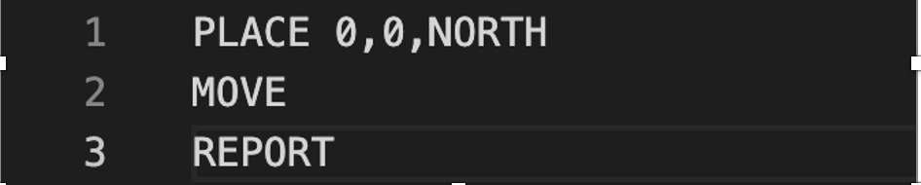

Result

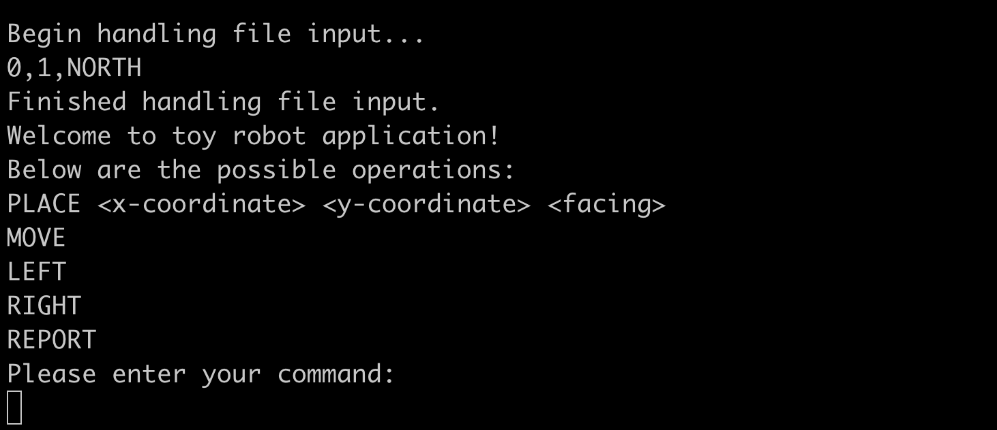

## Case: Should be able to wait for user manual input on console directly, if file is not found in the designated location

File location

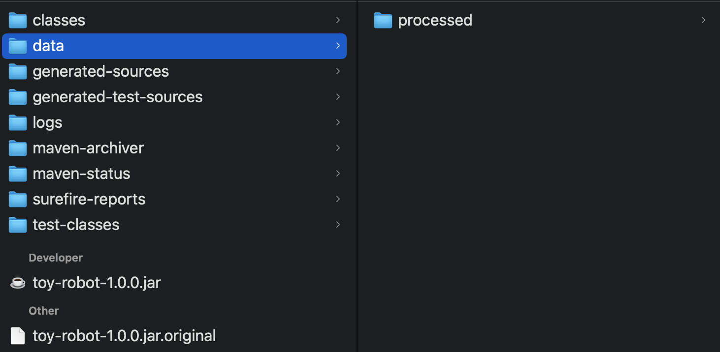

Result

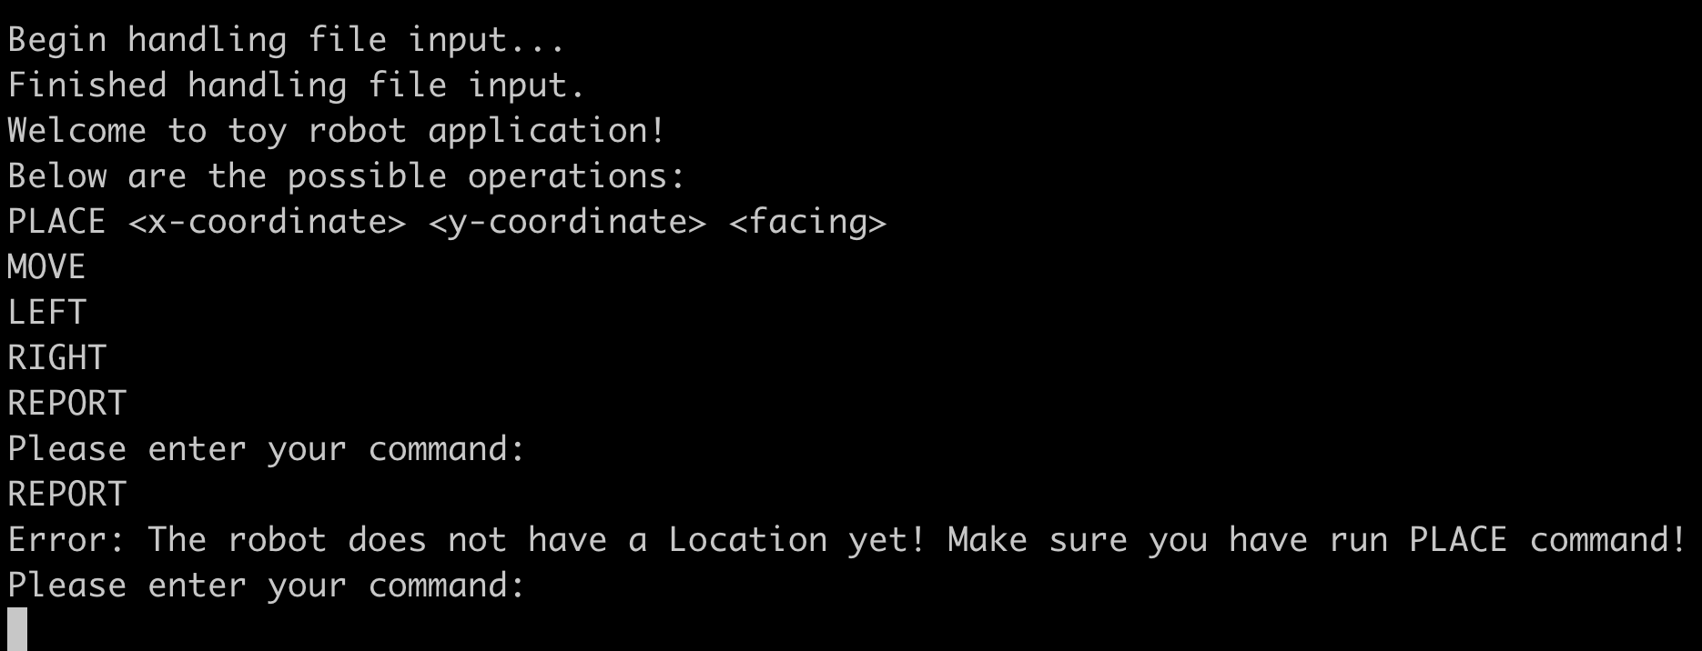

## Case: Should be able to process the commands in file input correctly



## Case: Should be able to process the file even if there is empty line at file end

File content

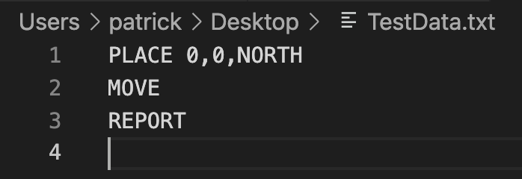

Result

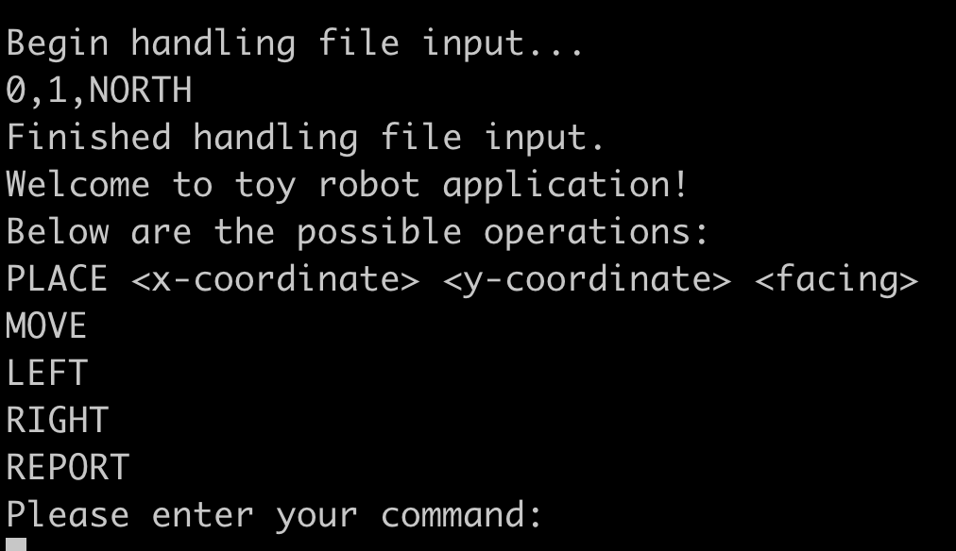

## Case: Should be able to throw error if any of the commands is invalid

File content

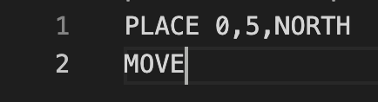

Result

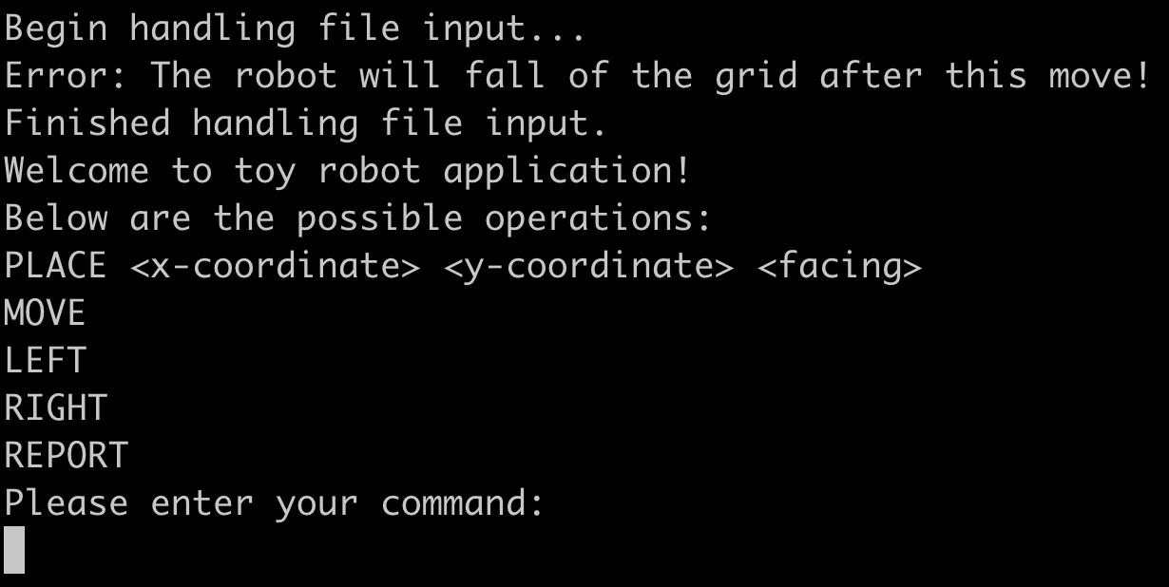

## Case: Should be able to rename file after processing

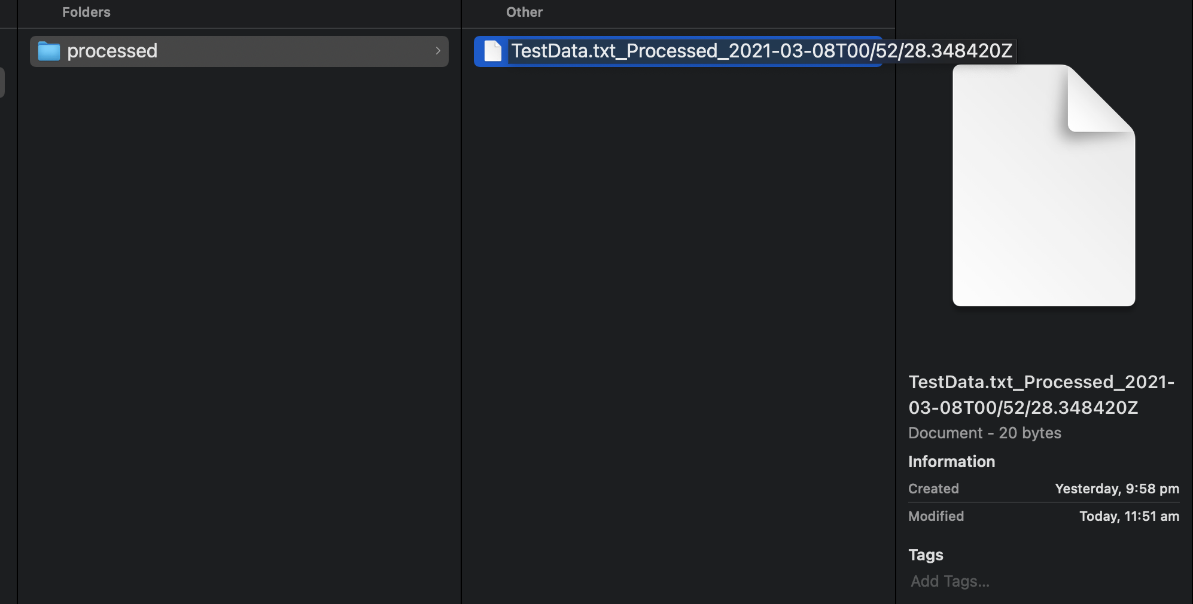

# Manual console input

## Case: Should be able to throw error if user input is empty

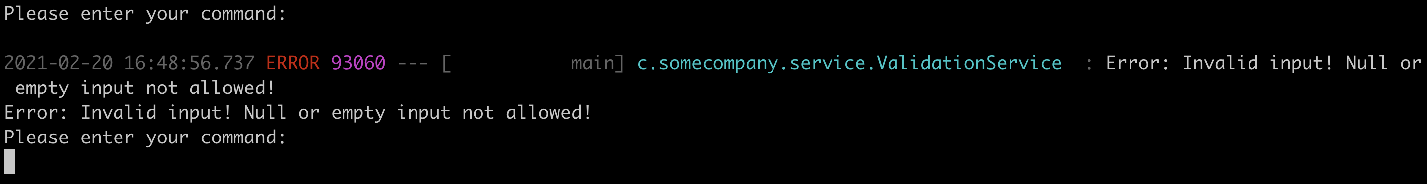

## Case: Should be able to throw error if command is invalid

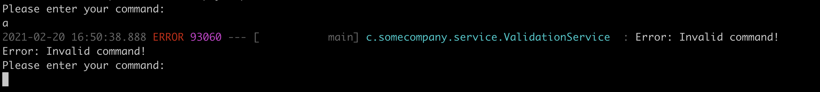

## Case: Should be able to throw error if the PLACE command has invalid format (More than 2 parts including the command)

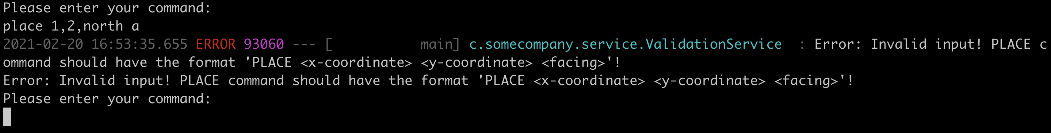

## Case: Should be able to throw error if the PLACE command has invalid format (More than 3 elements in the part of the params)

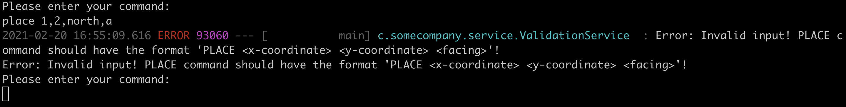

## Case: Should be able to throw error if the MOVE command has more than 1 part (it should contain only the command)

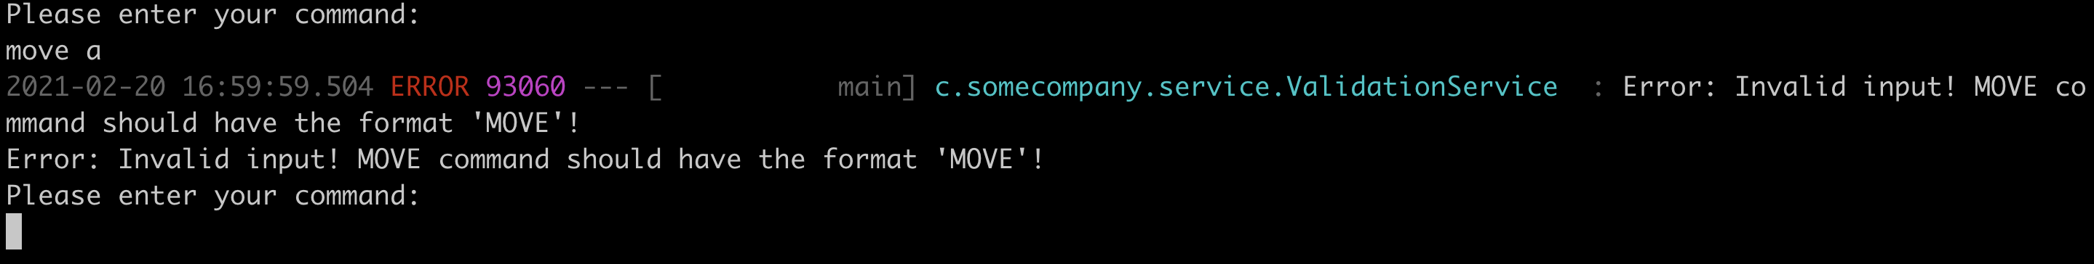

## Case: Should be able to throw error if the LEFT command has more than 1 part (it should contain only the command)

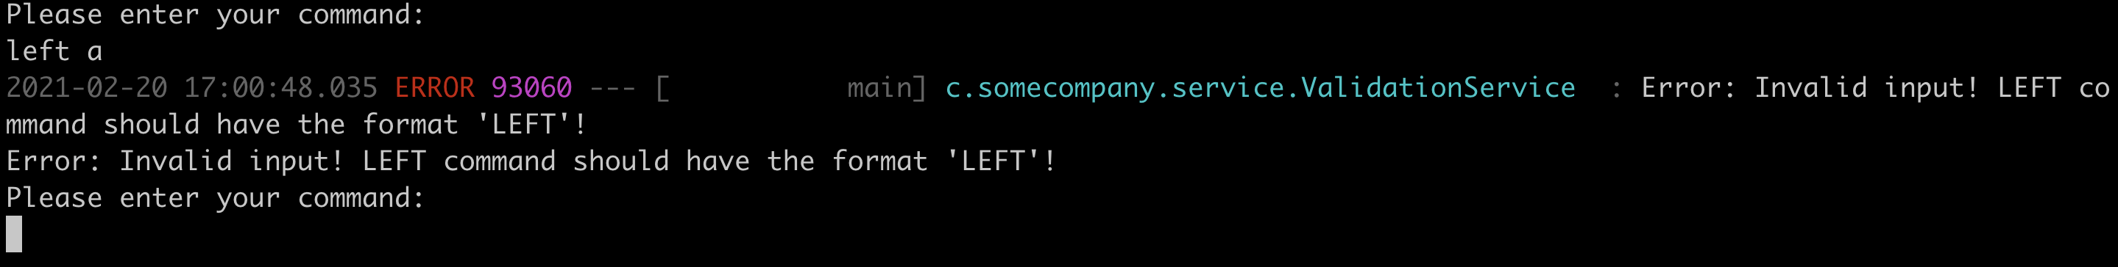

## Case: Should be able to throw error if the RIGHT command has more than 1 part (it should contain only the command)

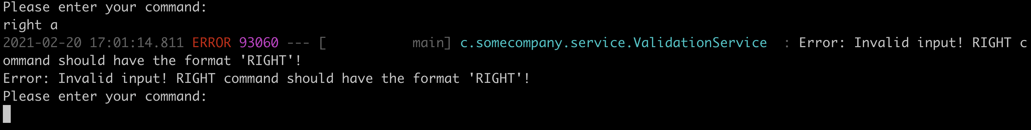

## Case: Should be able to throw error if the REPORT command has more than 1 part (it should contain only the command)

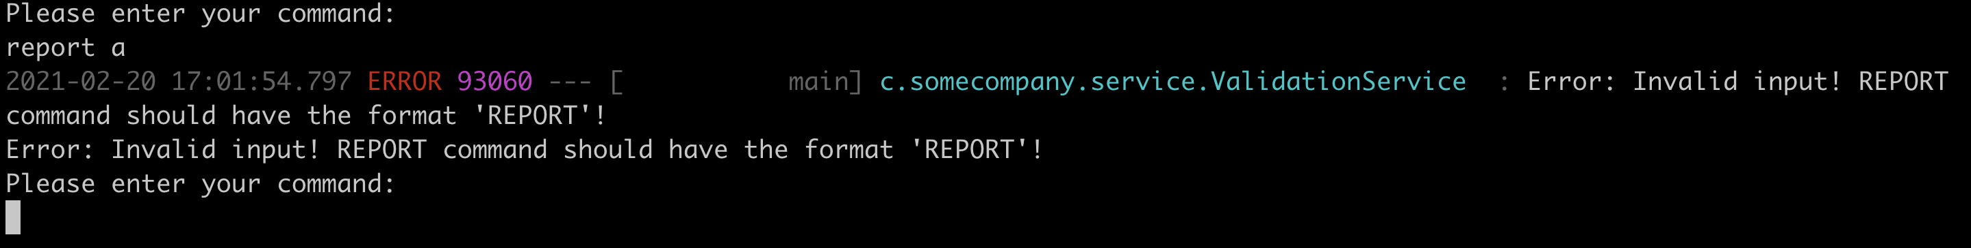

# PLACE command

## Case: Should be able to place the robot on the table

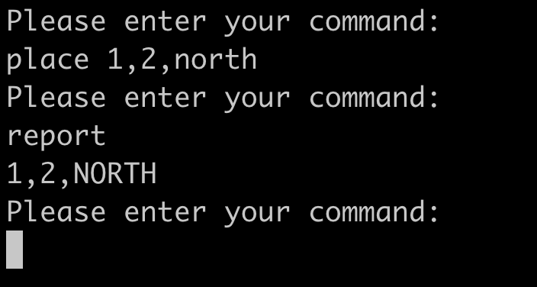

## Case: Should be able to throw error if the x-coordinate param is not an integer

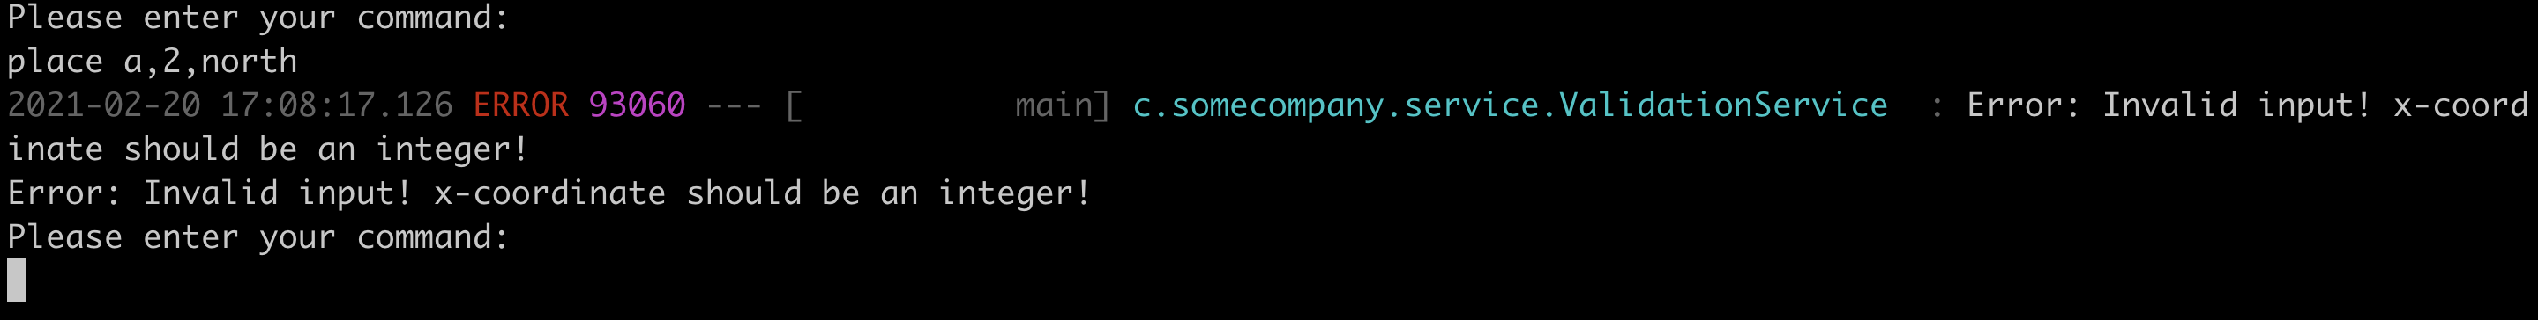

## Case: Should be able to throw error if attempt to place the robot on the table with the x-coordinate < 0

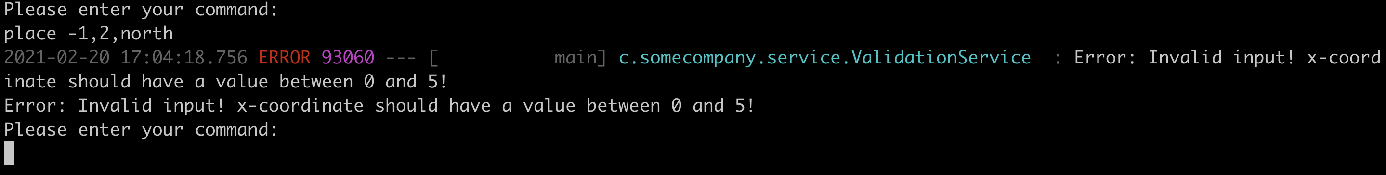

## Case: Should be able to throw error if attempt to place the robot on the table with the x-coordinate > 5

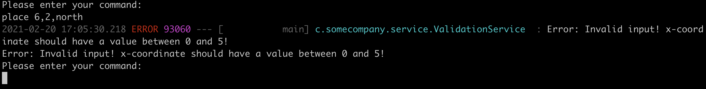

## Case: Should be able to throw error if the y-coordinate param is not an integer

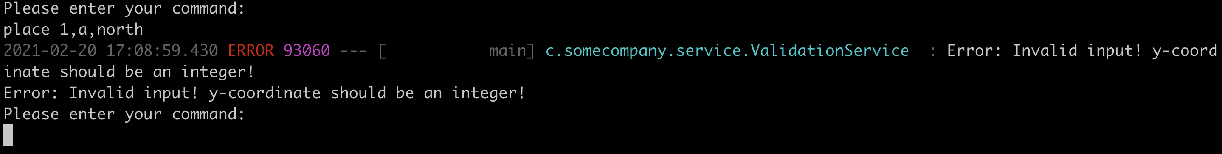

## Case: Should be able to throw error if attempt to place the robot on the table with the y-coordinate < 0

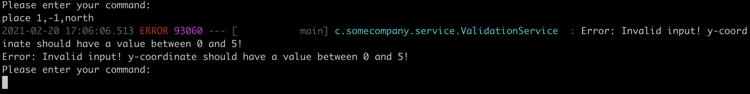

## Case: Should be able to throw error if attempt to place the robot on the table with the y-coordinate > 5

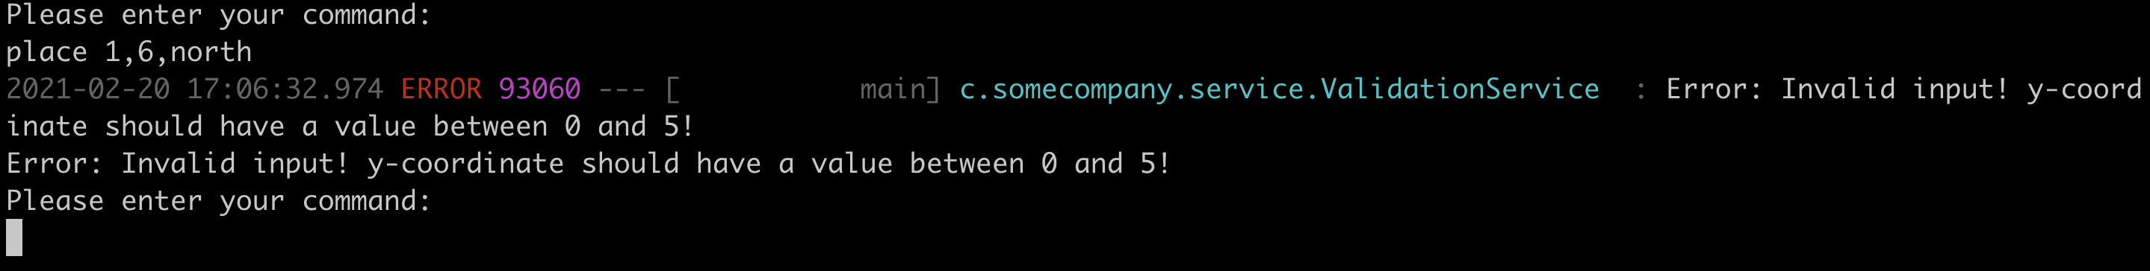

## Case: Should be able to throw error if the facing is invalid

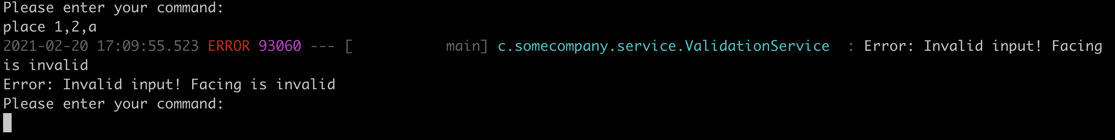

# PLACE_OBSTACLE command

## Case: Should be able to place obstacle

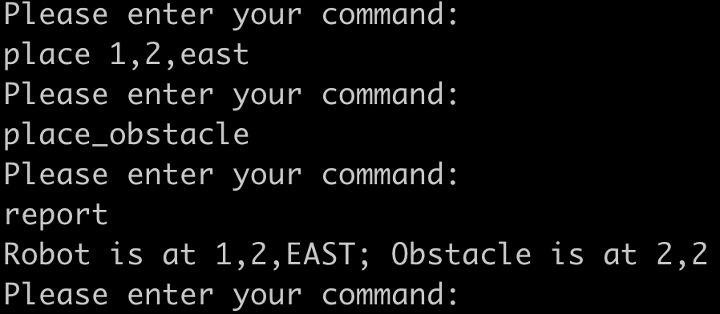

## Case: Should be able to throw error if attempt to place obstacle but robot does not have location

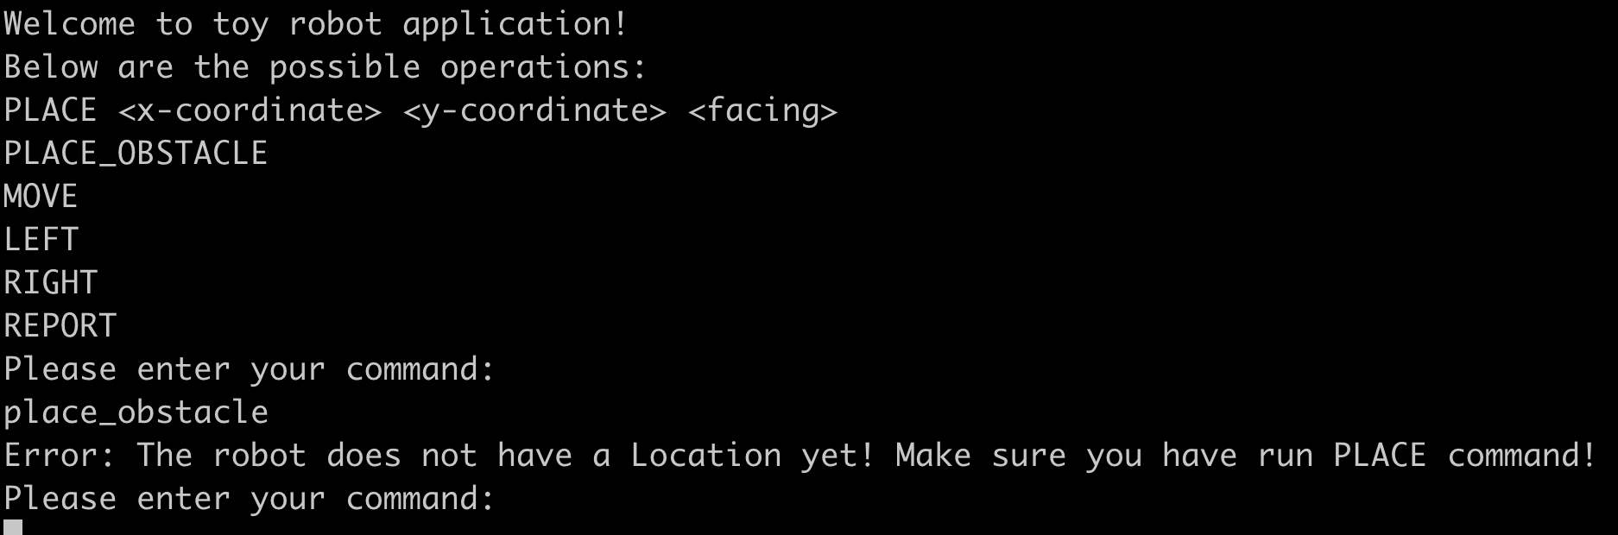

## Case: Should be able to throw error if attempt to place obstacle when robot is at east fringe

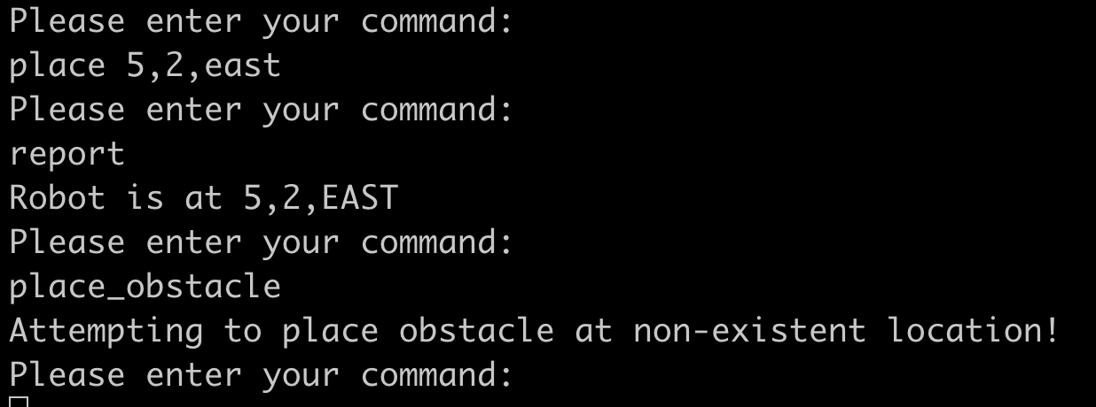

## Case: Should be able to throw error if attempt to place obstacle when robot is at south fringe

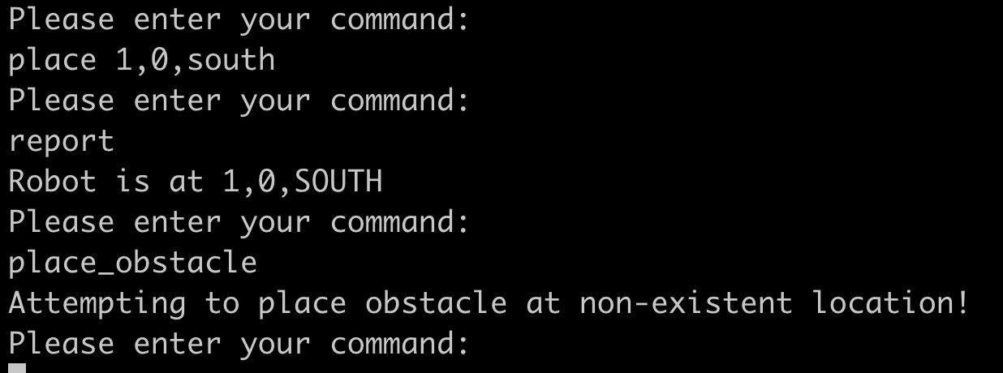

## Case: Should be able to throw error if attempt to place obstacle when robot is at west fringe

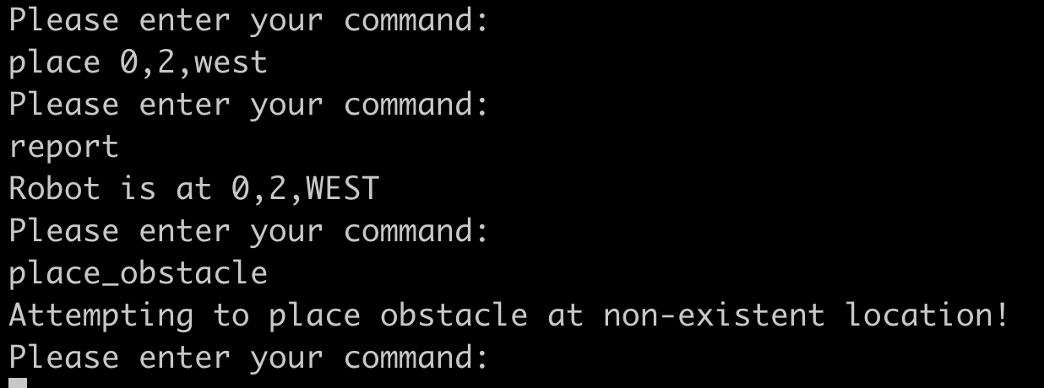

## Case: Should be able to throw error if attempt to place obstacle when robot is at north fringe

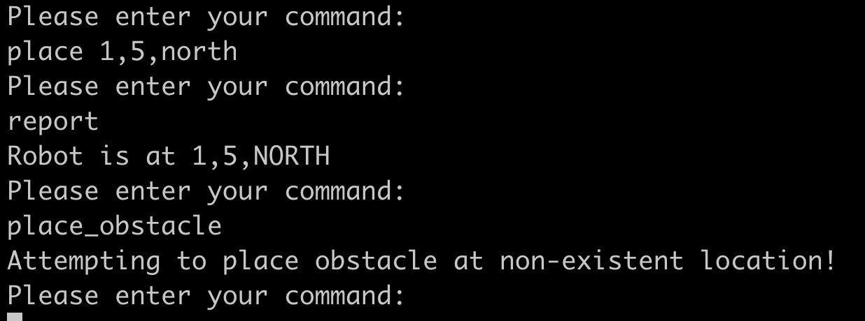

# MOVE command

## Case: Should be able to move robot east

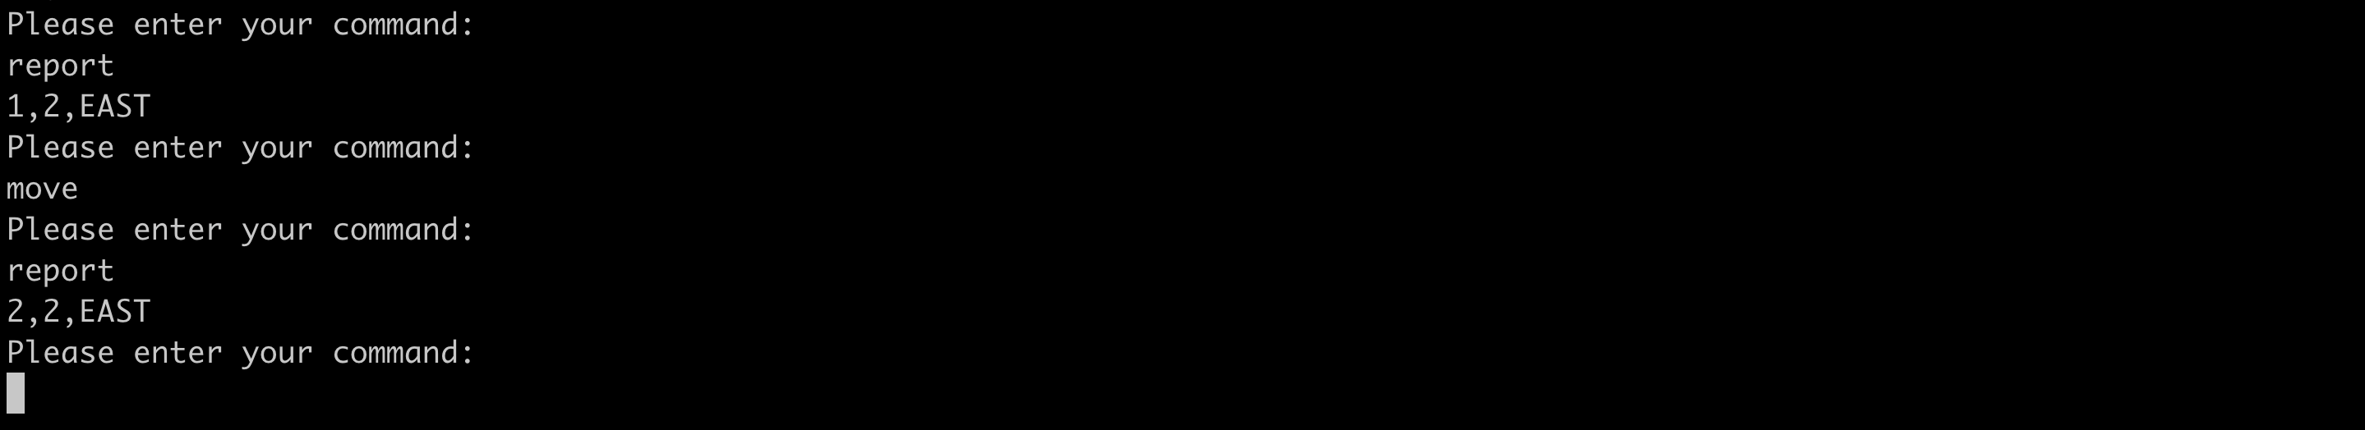

## Case: Should be able to move robot south

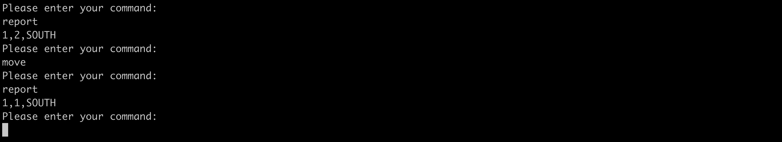

## Case: Should be able to move robot west

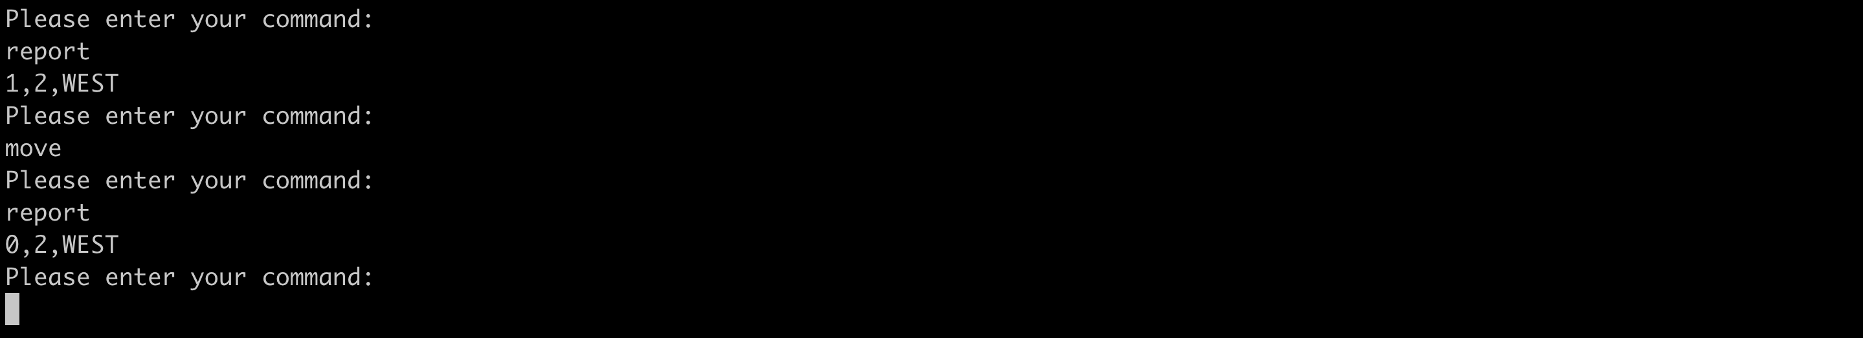

## Case: Should be able to move robot north

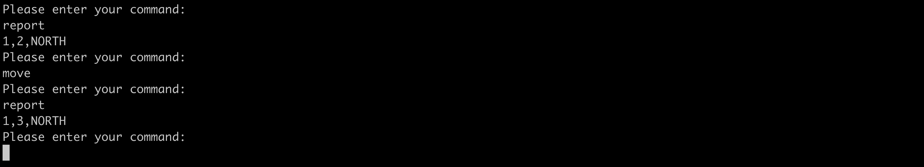

## Case: Should be able to throw error on MOVE command if robot does not have location

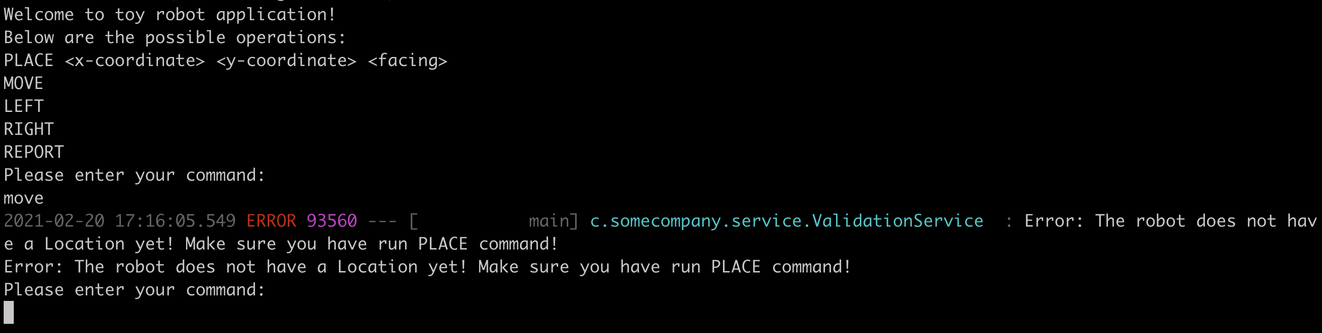

## Case: Should be able to throw error if robot will fall off table after moving east

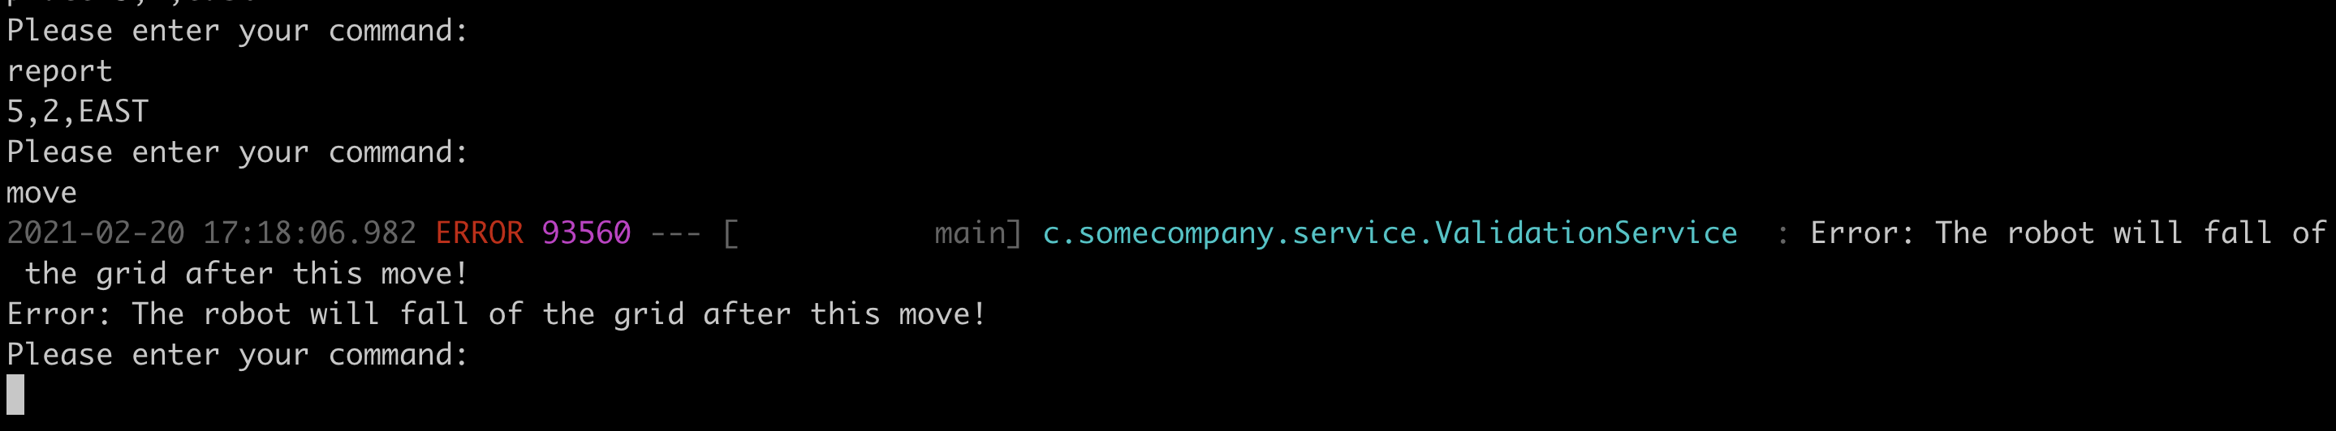

## Case: Should be able to throw error if robot will fall off table after moving south

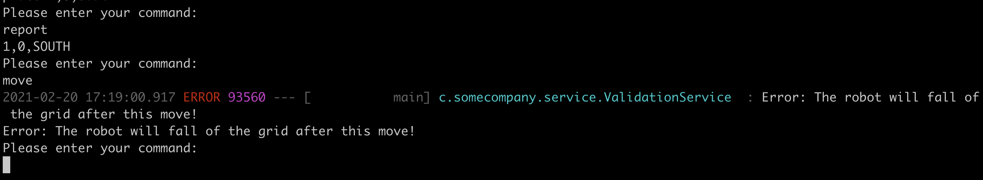

## Case: Should be able to throw error if robot will fall of table after moving west

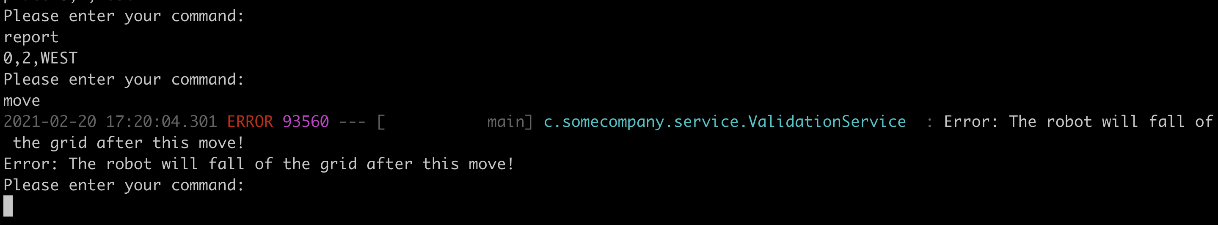

## Case: Should be able to throw error if robot will fall of table after moving north

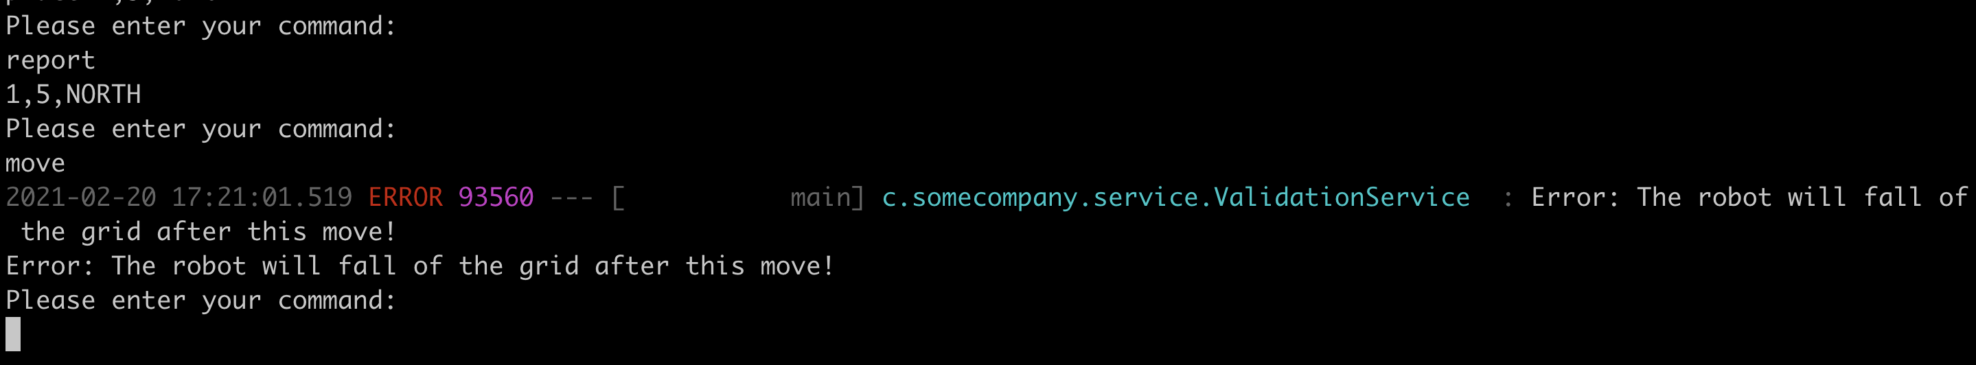

## Case: Should be able to throw error if robot will hit an obstacle after moving east

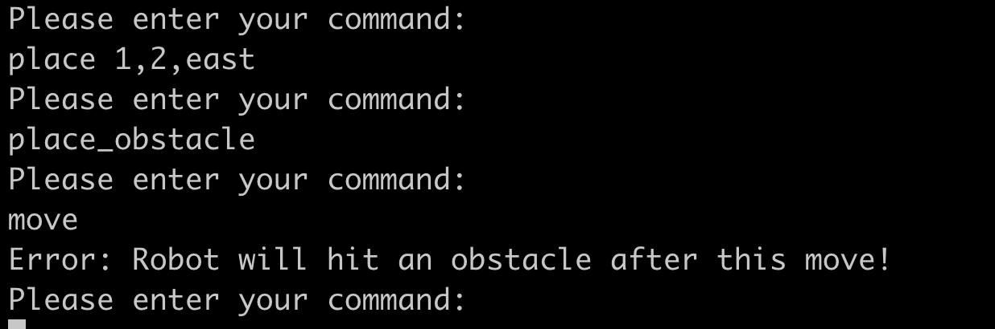

## Case: Should be able to throw error if robot will hit an obstacle after moving south

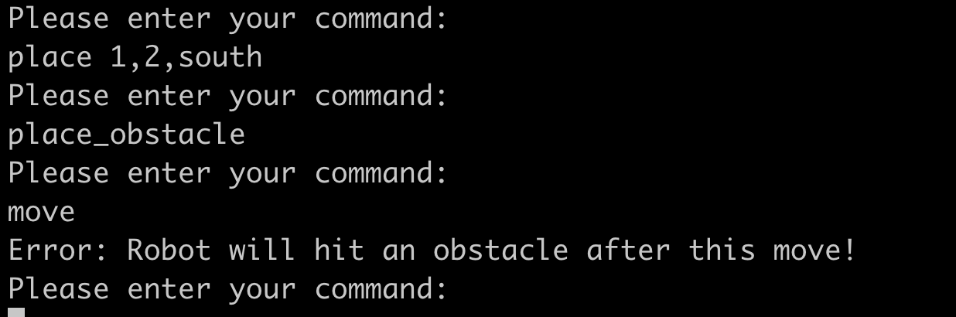

## Case: Should be able to throw error if robot will hit an obstacle after moving west

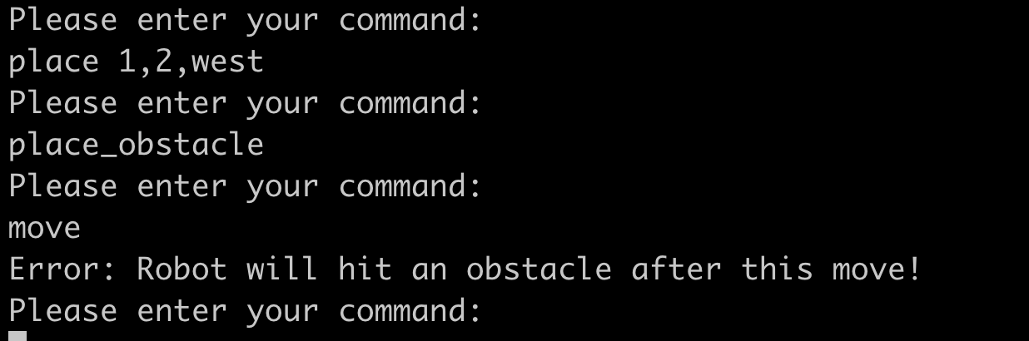

## Case: Should be able to throw error if robot will hit an obstacle after moving north

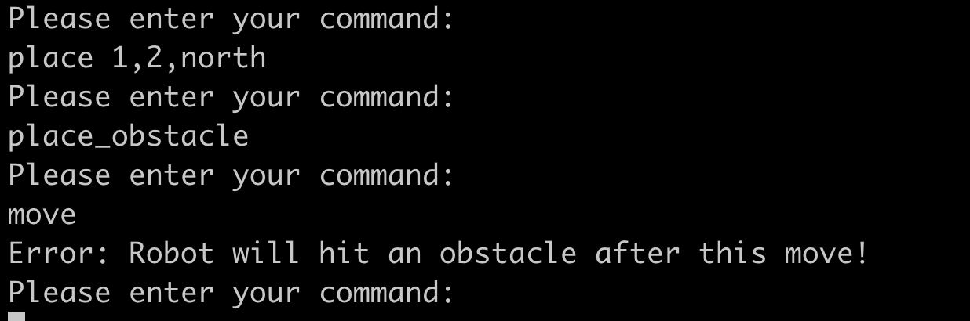

# LEFT command

## Case: Should be able to turn the robot to face north if it is facing east

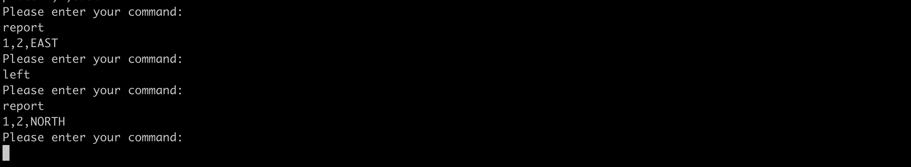

## Case: Should be able to turn the robot to face west if it is facing north

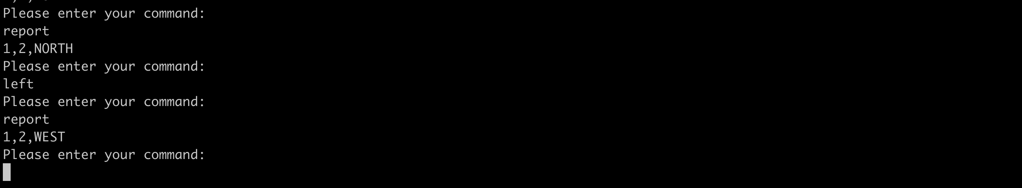

## Case: Should be able to turn the robot to face south if it is facing west

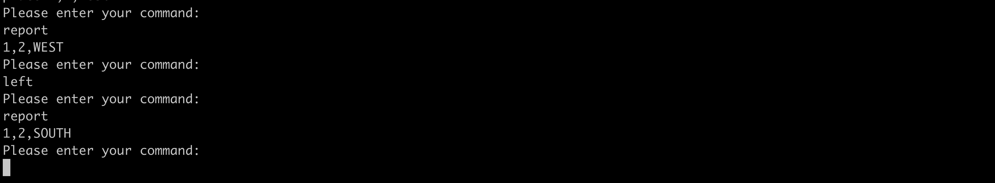

## Case: Should be able to turn the robot to face east if it is facing south

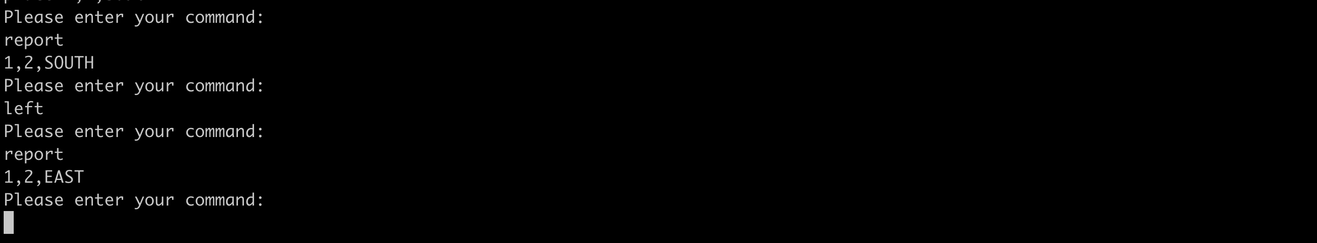

## Case: Should be able to throw error on LEFT command if robot does not have location

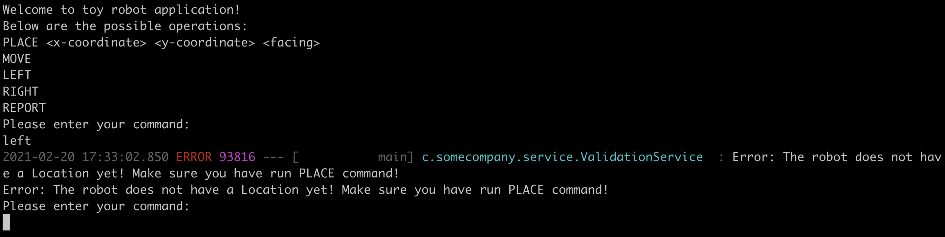

# RIGHT command

## Case: Should be able to turn the robot to face south if it is facing east

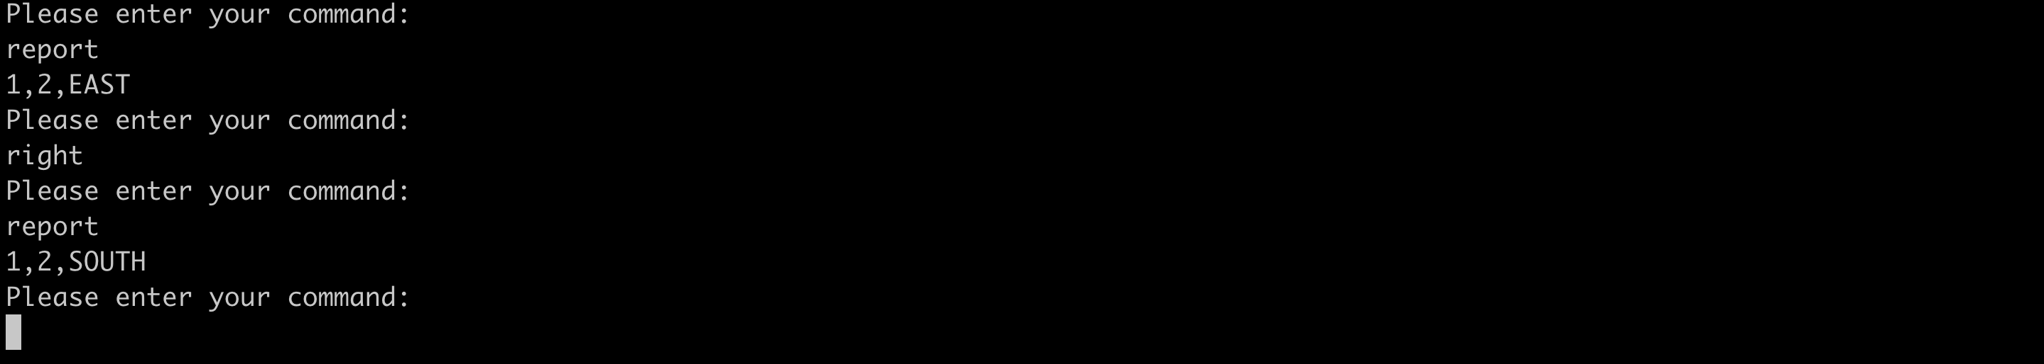

## Case: Should be able to turn the robot to face west if it is facing south

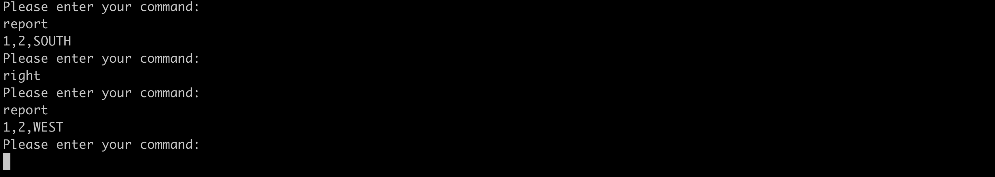

## Case: Should be able to turn the robot to face north if it is facing west

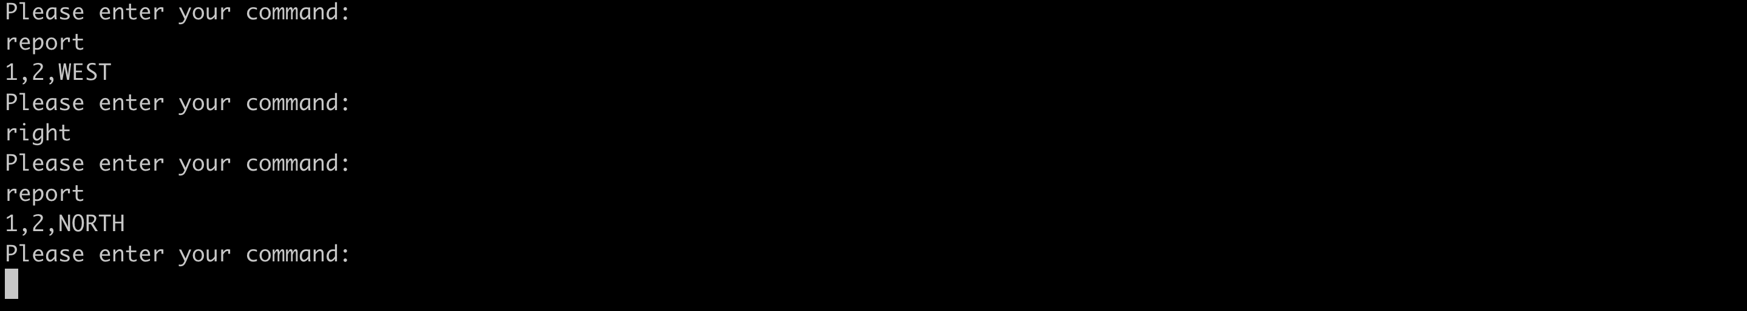

## Case: Should be able to turn the robot to face east if it is facing north

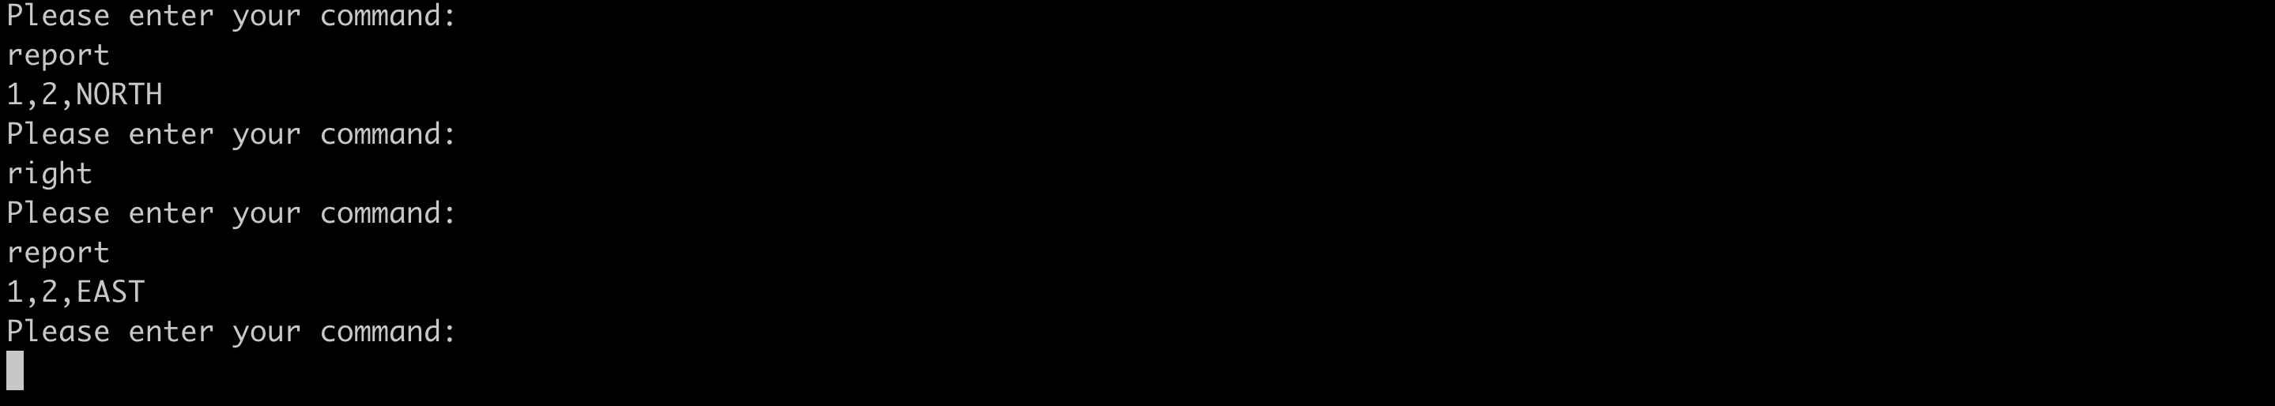

## Case: Should be able to throw error on RIGHT command if robot does not have location

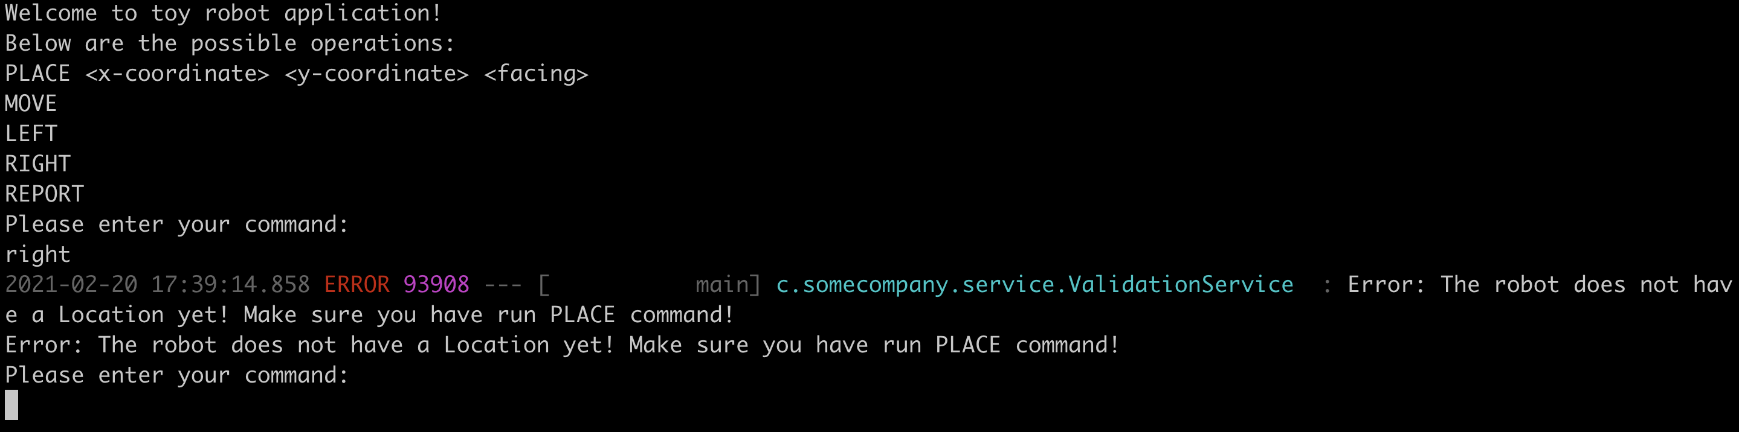

# REPORT command

## Case: Should be able to report the robot's location only when obstacle is not yet placed

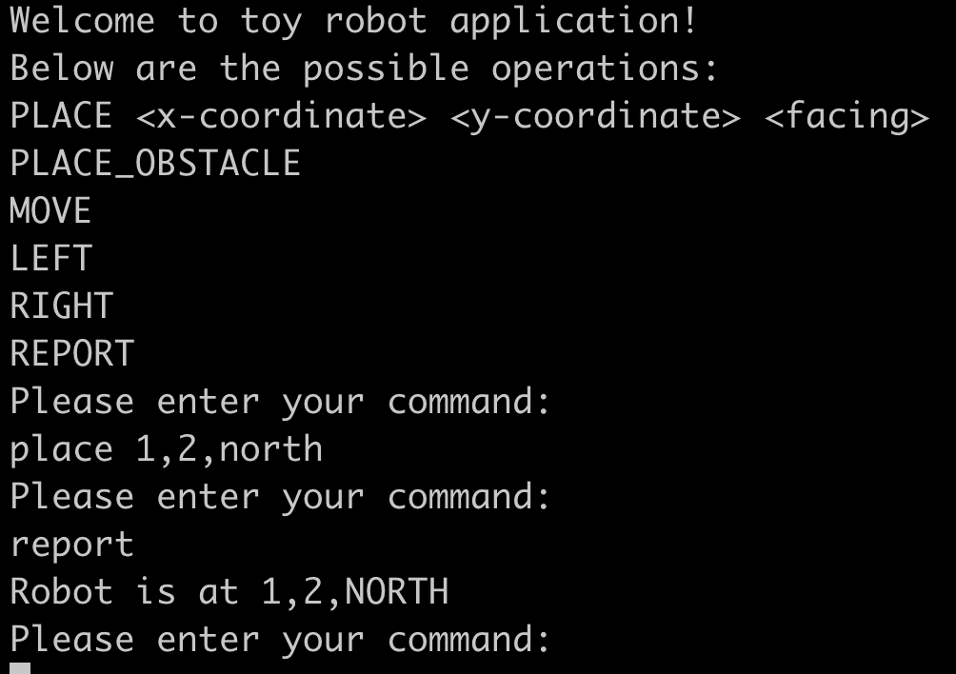

## Case: Should be able to report both the robot and obstacle's location only when obstacle is yet placed

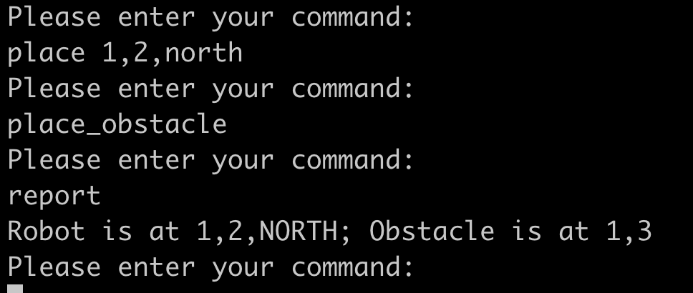

## Case: Should be able to throw error on REPORT command if robot does not have location

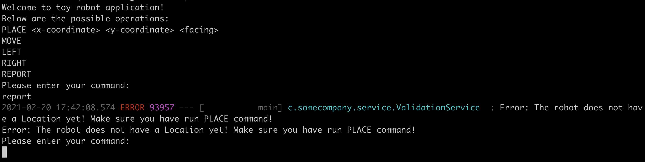

# Logging

## Case: Should be able to log system logs

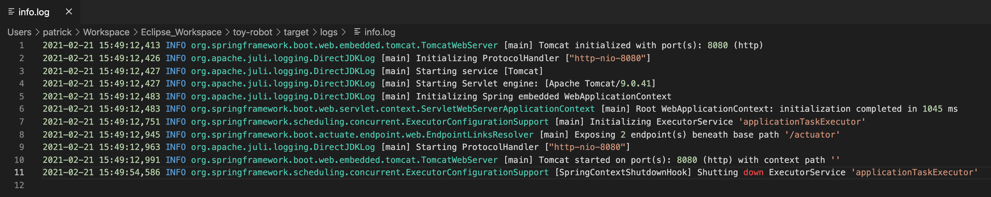

## Case: Should be able to log error logs related to program run

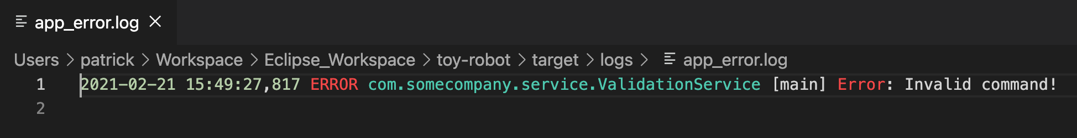

## Case: Should not show the logs in the console

